All Data for All Insured Patients

All Patient Details and Card Info. for Self-Paid Patients
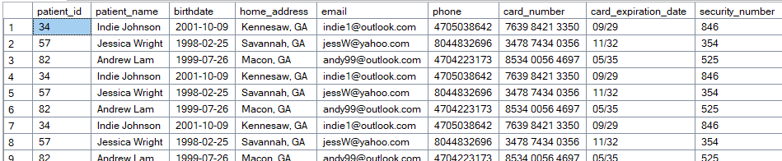

Joined Patient, Visit, and Employee Tables

All Employee Info in Alphabetical Order
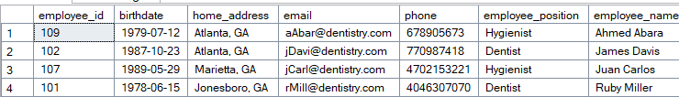

Total Price Paid by Patients
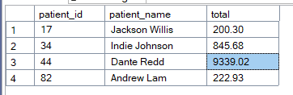

All Info for Patient that Paid the Most

